SVKM’s NMIMS
School of Technology Management & Engineering, Chandigarh
A.Y. 2025 - 26
Course: Database Management Systems
Project Report
Program | MBA Tech AI
Semester | IV
Name of the Project: | Banking System Database
Details of Project Members
Batch | Roll No. | Name
 | R015 | Naitik Gokharu
 | R027 | Jash Kankariya
 | R039 | Netray Nahar
Date of Submission: 10/04/2026

Contribution of each project Members:
Roll No. | Name: | Contribution
R015 | Naitik Gokharu | - Making ER diagram and Relational Schema  - Debugging Code  - Populating Data
R027 | Jash Kankariya | - Built Frontend  - Initial Hardcoding SQL  - Debugging Code  - Making Github repo
R039 | Netray Nahar | - Writing all queries  - Making the report  - Debugging Code  - Making all tables

Github link of your project: https://github.com/jashkankariya/Banking-System-Database

Note:
- Create a readme file if you have multiple files
- All files must be properly named (Example:R004_DBMSProject)
- Submit all relevant files of your work ( Report, all SQL files, Any other files)
- Plagiarism is highly discouraged (Your report will be checked for plagiarism)
Rubrics for the Project evaluation:
First phase of evaluation:  Innovative Ideas (5 Marks)  Design and Partial implementation (5 Marks) | 10 marks
Final phase of evaluation  Implementation, presentation and viva, Self-Learning and Learning Beyond classroom | 10 marks

Project Report

Banking System Database

by
Naitik Gokharu, Roll number: R015
Jash Kankariya, Roll number: R027
Netray Nahar, Roll number: R039

Course: DBMS

AY: 2025-26

Table of Contents

Sr no. | Topic | Page no.
1 | Storyline
2 | Components of Database Design
3 | Entity Relationship Diagram
4 | Relational Model
5 | Normalization
6 | SQL Queries
7 | Learning from the Project
8 | Project Demonstration
9 | Self-learning beyond classroom
10 | Learning from the project
8 | Challenges faced
9 | Conclusion

I. Storyline
SECTION I : Storyline
Our Bank is a mid-sized commercial banking institution operating across major cities in India, including Mumbai, Delhi, and Pune. The bank operates through three subsidiary banks: Naitik Financial Bank, Jash Fincorp, and Netray Cooperative Bank, collectively managing 10 branches, over 12 customers, and a diverse portfolio of financial products including savings accounts, current accounts, fixed deposits, recurring deposits, loans, and debit/credit cards.
As the bank expanded its operations, managing customer data, account transactions, loan records, and employee information through manual processes became increasingly error-prone and inefficient. The management decided to implement a centralized relational database system to digitize and streamline all banking operations.
The proposed Banking System Database is designed to:
- Maintain complete records of all customers with KYC verification status
- Track multiple account types (Savings, Current, Fixed Deposit, Recurring Deposit) per customer
- Record every financial transaction with a unique reference number for audit trails
- Manage loan disbursements, EMI schedules, and repayment tracking
- Issue and manage debit and credit cards linked to customer accounts
- Maintain branch and employee records across all locations
This database serves as the backbone for the bank's core banking software, enabling tellers, loan officers, branch managers, and IT staff to access and update records in real time while maintaining data integrity and security.

II. Components of Database Design
Entities and Their Attributes

1. BANK
Primary Key: bank_id
Attributes: bank_name, headquarters, established_year, swift_code
Description: Stores details of the parent banking organizations.
2. BRANCH
Primary Key: branch_id | Foreign Key: bank_id → BANK
Attributes: branch_name, city, state, ifsc_code
Description: Each bank operates multiple branches across cities.
3. EMPLOYEE
Primary Key: emp_id | Foreign Key: branch_id → BRANCH
Attributes: first_name, last_name, role, salary, hire_date
Description: Bank staff assigned to specific branches with defined roles.
4. CUSTOMER
Primary Key: customer_id | Unique: pan_number, email
Attributes: first_name, last_name, dob, email, phone, address, pan_number, kyc_status
Description: Individuals who hold accounts or loans with the bank.
5. ACCOUNT
Primary Key: account_id | Foreign Keys: customer_id → CUSTOMER, branch_id → BRANCH
Attributes: account_number, account_type, balance, open_date, status
Description: Financial accounts of various types held by customers.
6. TRANSACTION
Primary Key: txn_id | Foreign Key: account_id → ACCOUNT
Attributes: txn_type, amount, txn_date, description, reference_no
Description: Records of all financial movements in an account.
7. CARD
Primary Key: card_id | Foreign Key: account_id → ACCOUNT
Attributes: card_number, card_type, expiry_date, credit_limit, status
Description: Debit and credit cards linked to customer accounts.
8. LOAN
Primary Key: loan_id | Foreign Keys: customer_id → CUSTOMER, branch_id → BRANCH
Attributes: loan_type, principal, interest_rate, tenure_months, disburse_date, status
Description: Loan accounts sanctioned to customers by the bank.
9. LOAN_PAYMENT
Primary Key: payment_id | Foreign Key: loan_id → LOAN
Attributes: payment_date, emi_amount, principal_part, interest_part
Description: Records of EMI payments made against a loan.

Relationships and Cardinality
Relationship | Entities Involved | Cardinality | Participation
HAS | BANK : BRANCH | 1:N | Total on BRANCH side
WORKS_IN | EMPLOYEE : BRANCH | N:1 | Total on EMPLOYEE side
HOLDS | CUSTOMER : ACCOUNT | 1:N | Partial on CUSTOMER
BELONGS_TO | ACCOUNT : BRANCH | N:1 | Total on ACCOUNT side
PERFORMS | ACCOUNT : TRANSACTION | 1:N | Partial on ACCOUNT
LINKED_TO | CARD : ACCOUNT | N:1 | Total on CARD side
AVAILS | CUSTOMER : LOAN | 1:N | Partial on CUSTOMER
SANCTIONED_AT | LOAN : BRANCH | N:1 | Total on LOAN side
REPAID_BY | LOAN : LOAN_PAYMENT | 1:N | Partial on LOAN

III. Entity Relationship Diagram
Draw the ER diagram here. An example is shown:
You can also use software for drawing ER diagram
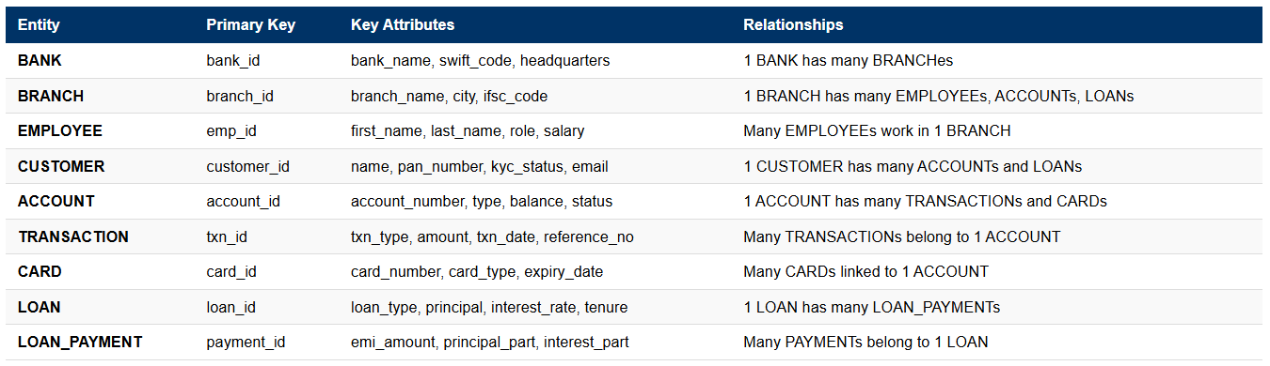
Major relationships in the diagram:
- BANK (1) ——: (N) BRANCH
- BRANCH (1) ——: (N) EMPLOYEE
- BRANCH (1) ——: (N) ACCOUNT
- CUSTOMER (1) ——: (N) ACCOUNT
- ACCOUNT (1) ——: (N) TRANSACTION
- ACCOUNT (1) ——: (N) CARD
- CUSTOMER (1) ——: (N) LOAN
- BRANCH (1) ——: (N) LOAN
- LOAN (1) ——: (N) LOAN_PAYMENT
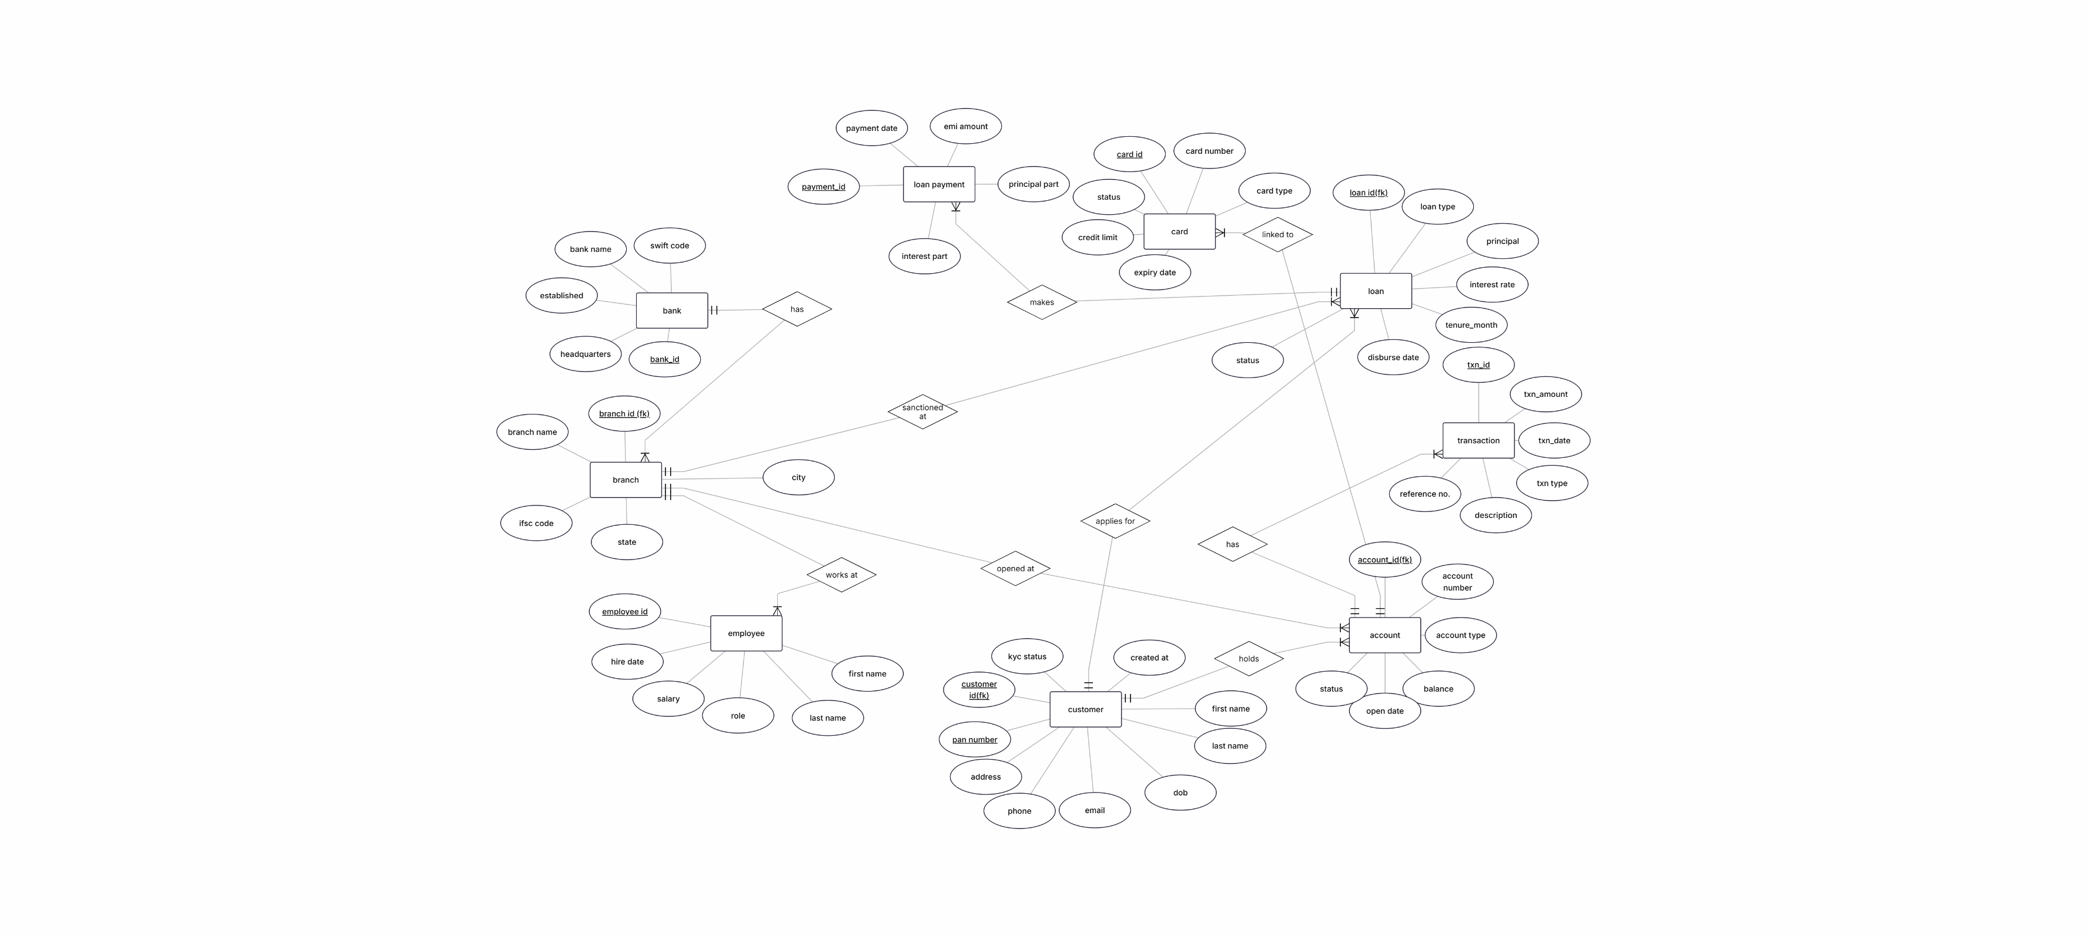

IV. Relational Model
Convert the ER diagram to the relational model using the concepts learned in the class.
List the various tables obtainedBANK (bank_id, bank_name, headquarters, established_year, swift_code)
- BRANCH (branch_id, bank_id, branch_name, city, state, ifsc_code)
- EMPLOYEE (emp_id, branch_id, first_name, last_name, role, salary, hire_date)
- CUSTOMER (customer_id, first_name, last_name, dob, email, phone, address, pan_number, kyc_status)
- ACCOUNT (account_id, customer_id, branch_id, account_number, account_type, balance, open_date, status)
- TRANSACTION (txn_id, account_id, txn_type, amount, txn_date, description, reference_no)
- CARD (card_id, account_id, card_number, card_type, expiry_date, credit_limit, status)
- LOAN (loan_id, customer_id, branch_id, loan_type, principal, interest_rate, tenure_months, disburse_date, status)
- LOAN_PAYMENT (payment_id, loan_id, payment_date, emi_amount, principal_part, interest_part)
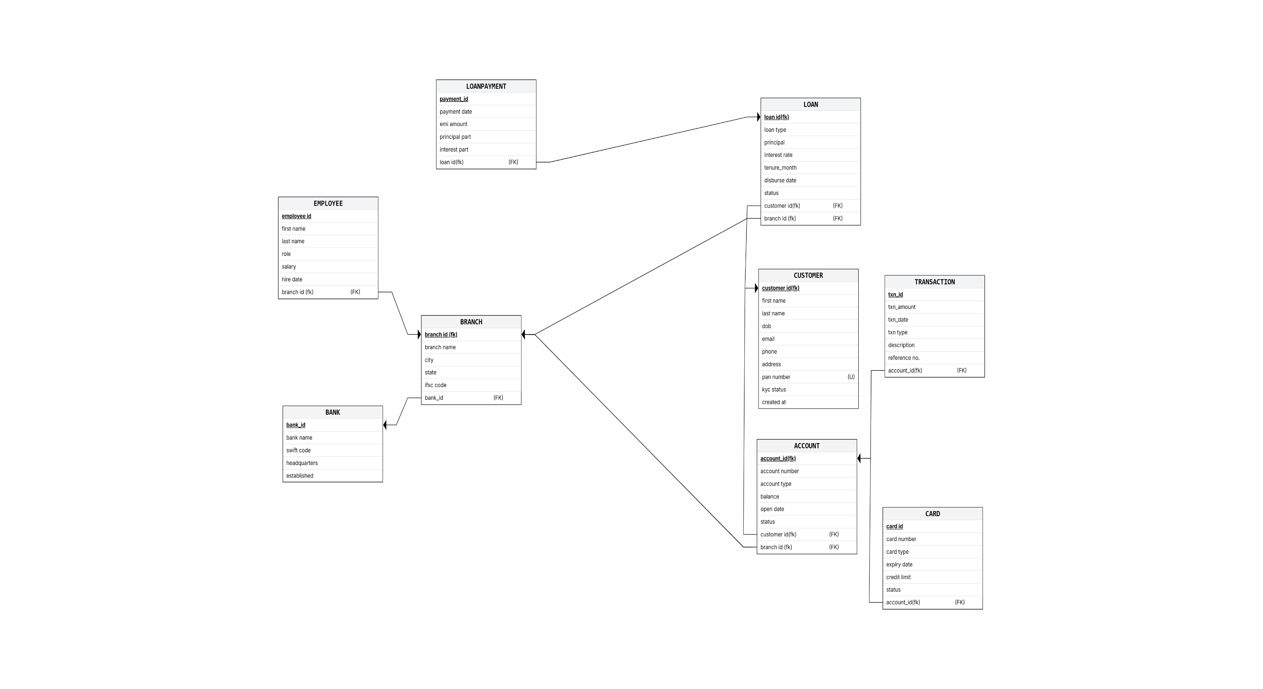

V. Normalization
First Normal Form (1NF)
Condition: All attributes must be atomic; no repeating groups.
Status: Satisfied ✓
All columns in every table hold single atomic values. Each row is uniquely identifiable via its primary key. No table contains multi-valued or composite attributes stored in a single column.
Second Normal Form (2NF)
Condition: Must be in 1NF and no partial dependency on a composite primary key.
Status: Satisfied ✓
All tables use single-column surrogate primary keys (auto-incremented integers). Since no table has a composite primary key, partial dependencies cannot exist. Every non-key attribute is fully dependent on the entire primary key.
Third Normal Form (3NF)
Condition: Must be in 2NF and no transitive dependency.
Status: Satisfied ✓
All non-key attributes depend directly on the primary key, not on each other. For example, branch details (city, state, ifsc_code) are stored in the BRANCH table and not repeated in ACCOUNT or LOAN tables, eliminating transitive dependencies.
Boyce-Codd Normal Form (BCNF)
Condition: For every functional dependency X → Y, X must be a superkey.
Status: Satisfied ✓
All functional dependencies have a superkey as the determinant. Candidate keys such as pan_number, account_number, ifsc_code, and card_number are enforced with UNIQUE constraints.

Table | 1NF | 2NF | 3NF | BCNF
BANK | ✓ | ✓ | ✓ | ✓
BRANCH | ✓ | ✓ | ✓ | ✓
EMPLOYEE | ✓ | ✓ | ✓ | ✓
CUSTOMER | ✓ | ✓ | ✓ | ✓
ACCOUNT | ✓ | ✓ | ✓ | ✓
TRANSACTION | ✓ | ✓ | ✓ | ✓
CARD | ✓ | ✓ | ✓ | ✓
LOAN | ✓ | ✓ | ✓ | ✓
LOAN_PAYMENT | ✓ | ✓ | ✓ | ✓

VI. SQL Queries
Using a DBMS software (SQLite3 or MySQL or any other of your choice):
- Create the tables
- Populate the tables (insert some meaningful data, at least 10 tuples for each relation)
- Run SQL queries (minimum 20) covering all concepts learned in the class
This section should contain the question, SQL code, and the output snapshot for each query.
Q1 : List all customers (SELECT, ORDER BY)
SELECT customer_id, CONCAT(first_name,' ',last_name) AS full_name,
email, phone, kyc_status
FROM CUSTOMER ORDER BY first_name ASC;
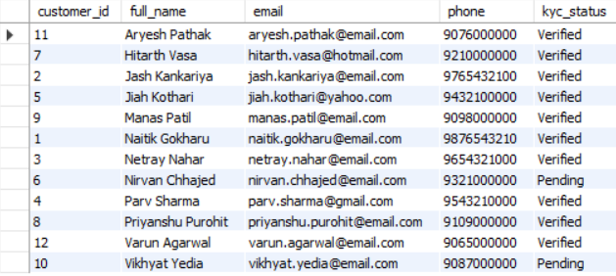
Q2 : Active accounts with balance > ₹1 lakh (WHERE, JOIN)
SELECT A.account_number, CONCAT(C.first_name,' ',C.last_name) AS customer_name,
A.account_type, A.balance
FROM ACCOUNT A INNER JOIN CUSTOMER C ON A.customer_id = C.customer_id
WHERE A.balance > 100000 AND A.status = 'Active'
ORDER BY A.balance DESC;
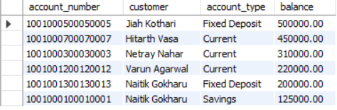

Q3 : Balance statistics by account type (GROUP BY, Aggregates)
SELECT account_type, COUNT(*) AS total_accounts,
SUM(balance) AS total_balance, AVG(balance) AS avg_balance,
MAX(balance) AS max_balance, MIN(balance) AS min_balance
FROM ACCOUNT GROUP BY account_type;
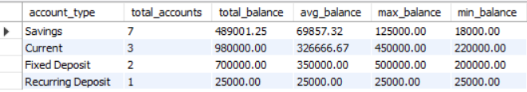
Q4 : Branches with total loan > ₹1 crore (HAVING)
SELECT B.branch_name, B.city, COUNT(L.loan_id) AS total_loans,
SUM(L.principal) AS total_loan_amount
FROM LOAN L INNER JOIN BRANCH B ON L.branch_id = B.branch_id
GROUP BY L.branch_id, B.branch_name, B.city
HAVING SUM(L.principal) > 10000000 ORDER BY total_loan_amount DESC;
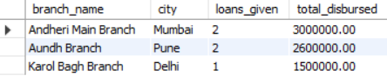
Q5 : Customer, account and branch details (3-table INNER JOIN)
SELECT C.customer_id, CONCAT(C.first_name,' ',C.last_name) AS customer_name,
A.account_number, A.account_type, A.balance, B.branch_name, B.city
FROM CUSTOMER C
INNER JOIN ACCOUNT A ON C.customer_id = A.customer_id
INNER JOIN BRANCH B ON A.branch_id = B.branch_id
ORDER BY C.customer_id; 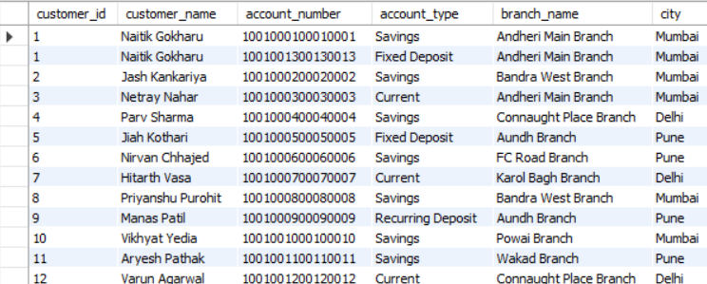

Q6 : All customers with loan details if any (LEFT JOIN)
SELECT C.customer_id, CONCAT(C.first_name,' ',C.last_name) AS customer_name,
L.loan_id, L.loan_type, L.principal, L.status
FROM CUSTOMER C LEFT JOIN LOAN L ON C.customer_id = L.customer_id
ORDER BY C.customer_id; 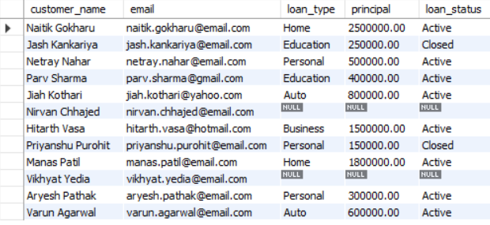
Q7 : Customers with above-average balance (Subquery)
SELECT CONCAT(C.first_name,' ',C.last_name) AS customer_name,
A.account_type, A.balance
FROM CUSTOMER C INNER JOIN ACCOUNT A ON C.customer_id = A.customer_id
WHERE A.balance > (SELECT AVG(balance) FROM ACCOUNT)
ORDER BY A.balance DESC;
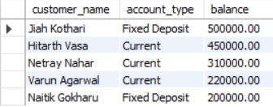
Q8 : Employees above their branch average salary (Correlated Subquery)
SELECT E.emp_id, CONCAT(E.first_name,' ',E.last_name) AS employee_name,
E.role, E.salary, B.branch_name
FROM EMPLOYEE E INNER JOIN BRANCH B ON E.branch_id = B.branch_id
WHERE E.salary > (
SELECT AVG(E2.salary) FROM EMPLOYEE E2 WHERE E2.branch_id = E.branch_id
) ORDER BY E.salary DESC;
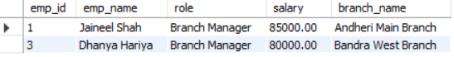
Q9 : Deposit and withdrawal summary per account (GROUP BY with CASE)
SELECT A.account_number, CONCAT(C.first_name,' ',C.last_name) AS customer_name,
COUNT(T.txn_id) AS total_transactions,
SUM(CASE WHEN T.txn_type='Deposit' THEN T.amount ELSE 0 END) AS total_deposits,
SUM(CASE WHEN T.txn_type='Withdrawal' THEN T.amount ELSE 0 END) AS total_withdrawals
FROM ACCOUNT A INNER JOIN CUSTOMER C ON A.customer_id = C.customer_id
LEFT JOIN TRANSACTION T ON A.account_id = T.account_id
GROUP BY A.account_id, A.account_number, customer_name;
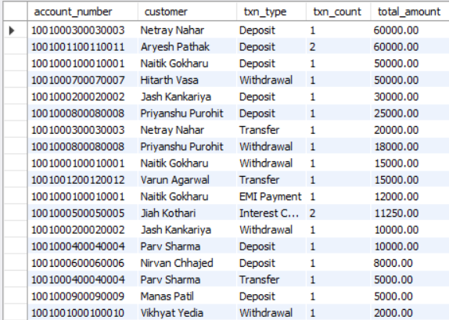
Q10 : Top 5 highest paid employees (ORDER BY, LIMIT)
SELECT emp_id, CONCAT(first_name,' ',last_name) AS employee_name, role, salary
FROM EMPLOYEE ORDER BY salary DESC LIMIT 5;
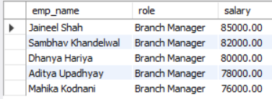
Q11 : Accounts opened in last 3 years (DATE functions)
SELECT account_number, account_type, balance, open_date,
TIMESTAMPDIFF(YEAR, open_date, CURDATE()) AS years_old
FROM ACCOUNT
WHERE open_date >= DATE_SUB(CURDATE(), INTERVAL 3 YEAR)
ORDER BY open_date DESC;
Q12 : Classify customers by balance (CASE statement)
SELECT CONCAT(C.first_name,' ',C.last_name) AS customer_name, A.balance,
CASE
WHEN A.balance >= 500000 THEN 'Premium Customer'
WHEN A.balance >= 100000 THEN 'Regular Customer'
WHEN A.balance >= 25000 THEN 'Basic Customer'
ELSE 'Low Balance'
END AS customer_category
FROM CUSTOMER C INNER JOIN ACCOUNT A ON C.customer_id = A.customer_id
ORDER BY A.balance DESC;
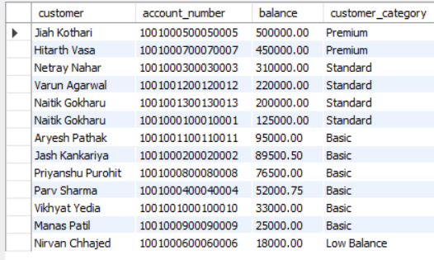
Q13 : Masked card number display (String functions)
SELECT card_id, card_type,
CONCAT('XXXX-XXXX-XXXX-', RIGHT(card_number, 4)) AS masked_card,
expiry_date, status
FROM CARD ORDER BY card_type;
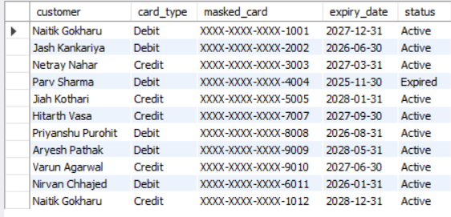
Q14 : Mark inactive accounts as Dormant (UPDATE)
UPDATE ACCOUNT SET status = 'Dormant'
WHERE account_id NOT IN (
SELECT DISTINCT account_id FROM TRANSACTION
WHERE txn_date >= DATE_SUB(CURDATE(), INTERVAL 1 YEAR)
) AND status = 'Active';

Q15 : Display all closed loans (SELECT with filter)
SELECT L.loan_id, CONCAT(C.first_name,' ',C.last_name) AS customer_name,
L.loan_type, L.principal, L.interest_rate, L.disburse_date, L.status
FROM LOAN L INNER JOIN CUSTOMER C ON L.customer_id = C.customer_id
WHERE L.status = 'Closed' ORDER BY L.disburse_date;
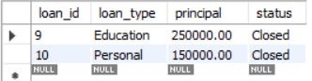
Q16 : Customer loan summary view (CREATE VIEW)
CREATE VIEW customer_loan_summary AS
SELECT C.customer_id, CONCAT(C.first_name,' ',C.last_name) AS customer_name,
COUNT(L.loan_id) AS total_loans, SUM(L.principal) AS total_borrowed,
AVG(L.interest_rate) AS avg_interest_rate
FROM CUSTOMER C LEFT JOIN LOAN L ON C.customer_id = L.customer_id
GROUP BY C.customer_id, customer_name;

SELECT * FROM customer_loan_summary;
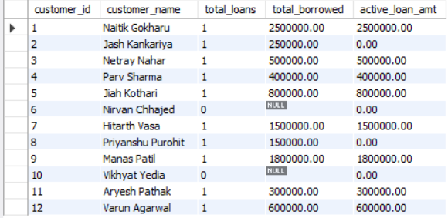
Q17 : Create indexes for performance (CREATE INDEX)
CREATE INDEX idx_account_customer ON ACCOUNT(customer_id);
CREATE INDEX idx_transaction_account ON TRANSACTION(account_id);
CREATE INDEX idx_loan_customer ON LOAN(customer_id);
CREATE INDEX idx_customer_pan ON CUSTOMER(pan_number);

Q18 : Fund transfer between accounts (TRANSACTION + COMMIT)
START TRANSACTION;
UPDATE ACCOUNT SET balance = balance - 10000 WHERE account_id = 1;
UPDATE ACCOUNT SET balance = balance + 10000 WHERE account_id = 2;
INSERT INTO TRANSACTION (account_id, txn_type, amount, txn_date, description, reference_no)
VALUES (1, 'Transfer', 10000, CURDATE(), 'Fund Transfer to Acc 2', 'TXN_TRANSFER_001');
COMMIT;

Q19 : Customers with both account and loan (EXISTS)
SELECT customer_id, CONCAT(first_name,' ',last_name) AS customer_name, email
FROM CUSTOMER C
WHERE EXISTS (SELECT 1 FROM ACCOUNT WHERE customer_id = C.customer_id)
AND EXISTS (SELECT 1 FROM LOAN WHERE customer_id = C.customer_id);
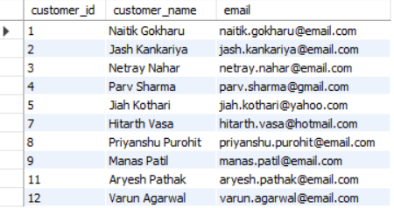
Q20 : Loan customers and FD holders combined (UNION ALL)
SELECT CONCAT(C.first_name,' ',C.last_name) AS name, 'Loan Customer' AS category
FROM CUSTOMER C INNER JOIN LOAN L ON C.customer_id = L.customer_id
UNION ALL
SELECT CONCAT(C.first_name,' ',C.last_name), 'FD Account Holder'
FROM CUSTOMER C INNER JOIN ACCOUNT A ON C.customer_id = A.customer_id
WHERE A.account_type = 'Fixed Deposit'; 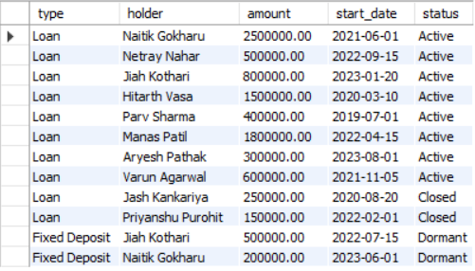
Q21 : Monthly EMI calculation for each loan (Mathematical functions, POW)
SELECT loan_id, CONCAT(C.first_name,' ',C.last_name) AS customer_name,
loan_type, principal, interest_rate, tenure_months,
ROUND(principal * (interest_rate/100/12) *
POW(1 + interest_rate/100/12, tenure_months) /
(POW(1 + interest_rate/100/12, tenure_months) - 1), 2) AS monthly_emi
FROM LOAN L INNER JOIN CUSTOMER C ON L.customer_id = C.customer_id
WHERE L.status = 'Active';
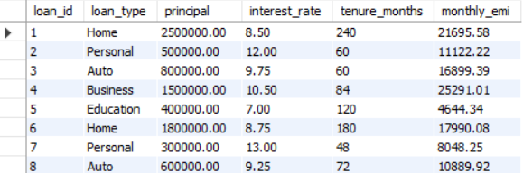

Q22 : Full customer profile with all linked records (Multi-table LEFT JOIN)
SELECT C.customer_id, CONCAT(C.first_name,' ',C.last_name) AS customer_name,
C.pan_number, C.kyc_status,
COUNT(DISTINCT A.account_id) AS total_accounts,
COUNT(DISTINCT L.loan_id) AS total_loans,
COUNT(DISTINCT CD.card_id) AS total_cards,
COALESCE(SUM(DISTINCT A.balance), 0) AS total_balance
FROM CUSTOMER C
LEFT JOIN ACCOUNT A ON C.customer_id = A.customer_id
LEFT JOIN LOAN L ON C.customer_id = L.customer_id
LEFT JOIN CARD CD ON A.account_id = CD.account_id
GROUP BY C.customer_id, customer_name, C.pan_number, C.kyc_status
ORDER BY total_balance DESC;
VI. Project demonstration

- Tools/software/ libraries used
- Screenshot and Description of the Demonstration of project ( If GUI is made)
Tool | Version | Purpose
MySQL | 9.6 | Database engine
MySQL Workbench | 8.0 | SQL query execution and DB management
HTML5 / CSS3 | — | Frontend interface
JavaScript (ES6) | — | Dynamic data rendering and interactivity
VS Code | Latest | Code editor
Google Chrome | Latest | Browser for running the frontend

The project frontend is a web-based Banking Management Interface developed in HTML, CSS, and JavaScript. It runs directly in a browser without any server setup. It includes 8 modules : Dashboard, Customers, Accounts, Transactions, Loans, Cards, Branches, and Employees : each displaying live data with add/search functionality. A DB Schema tab contains the ER Diagram, Relational Model, Normalization summary, and SQL query index

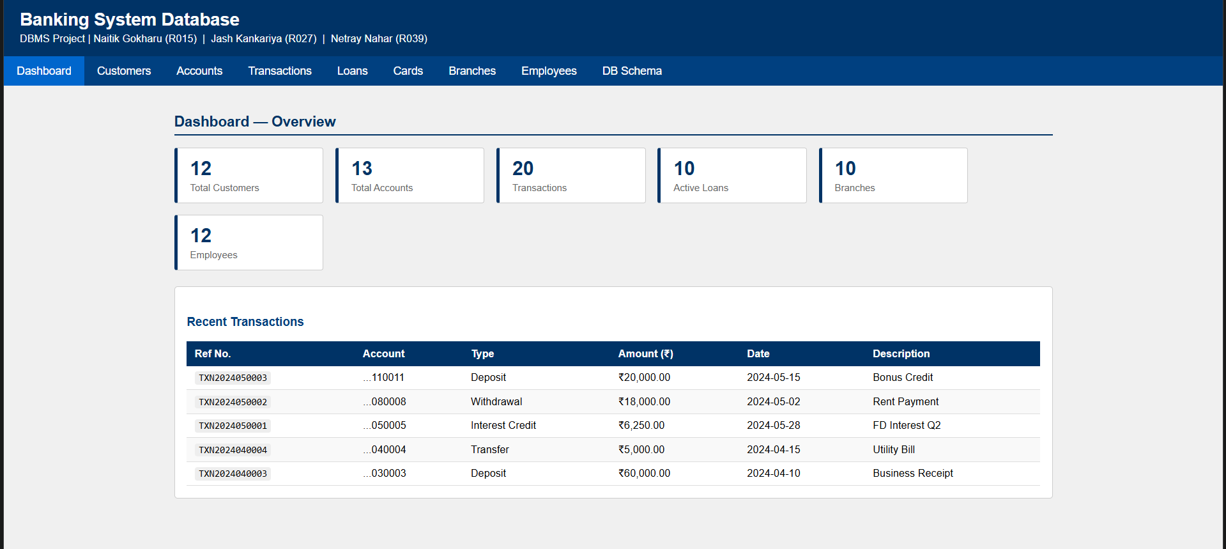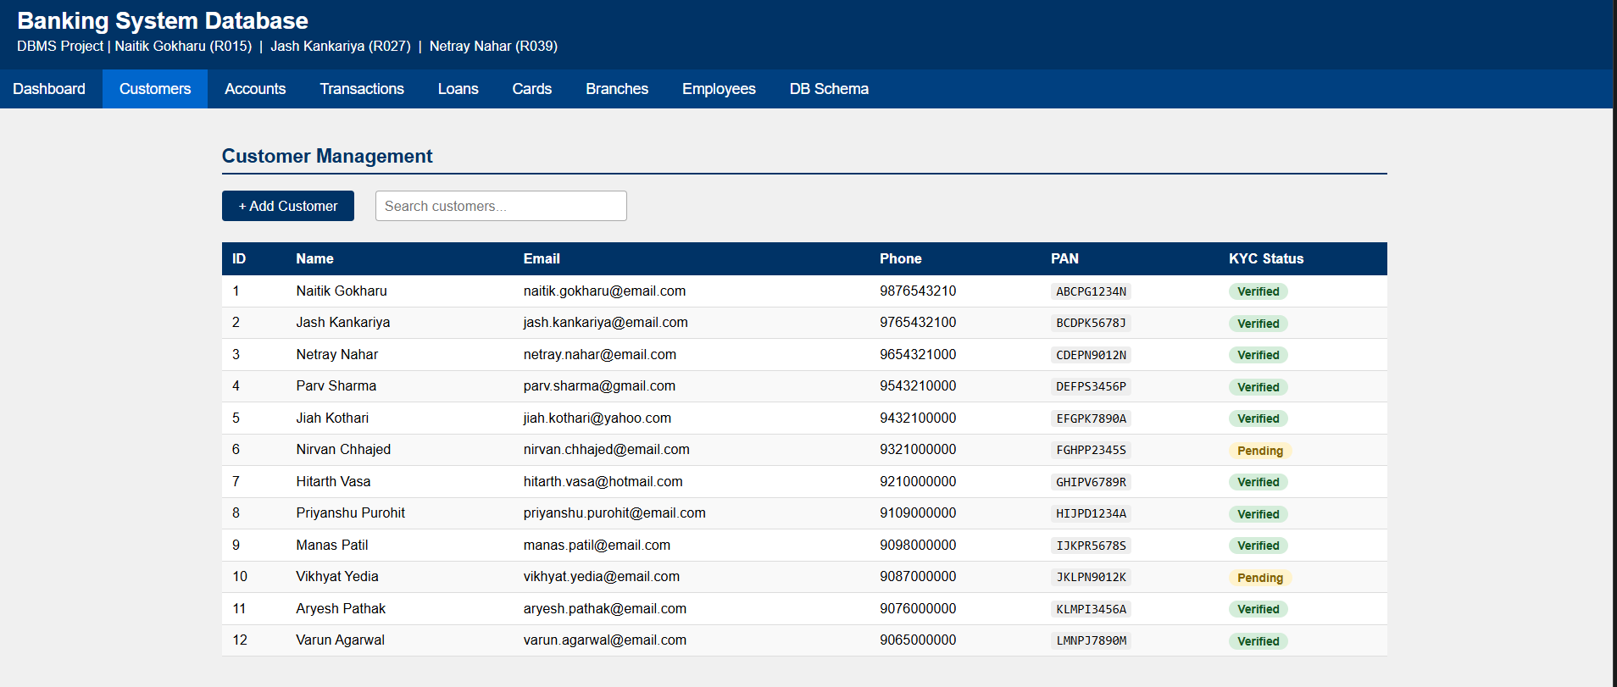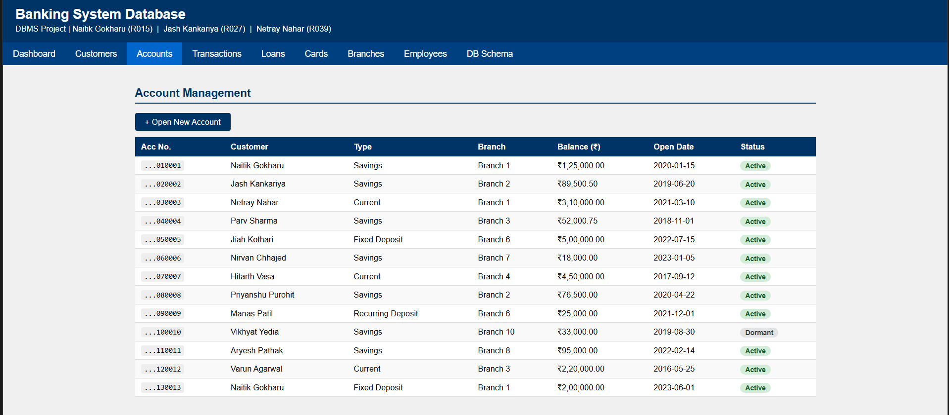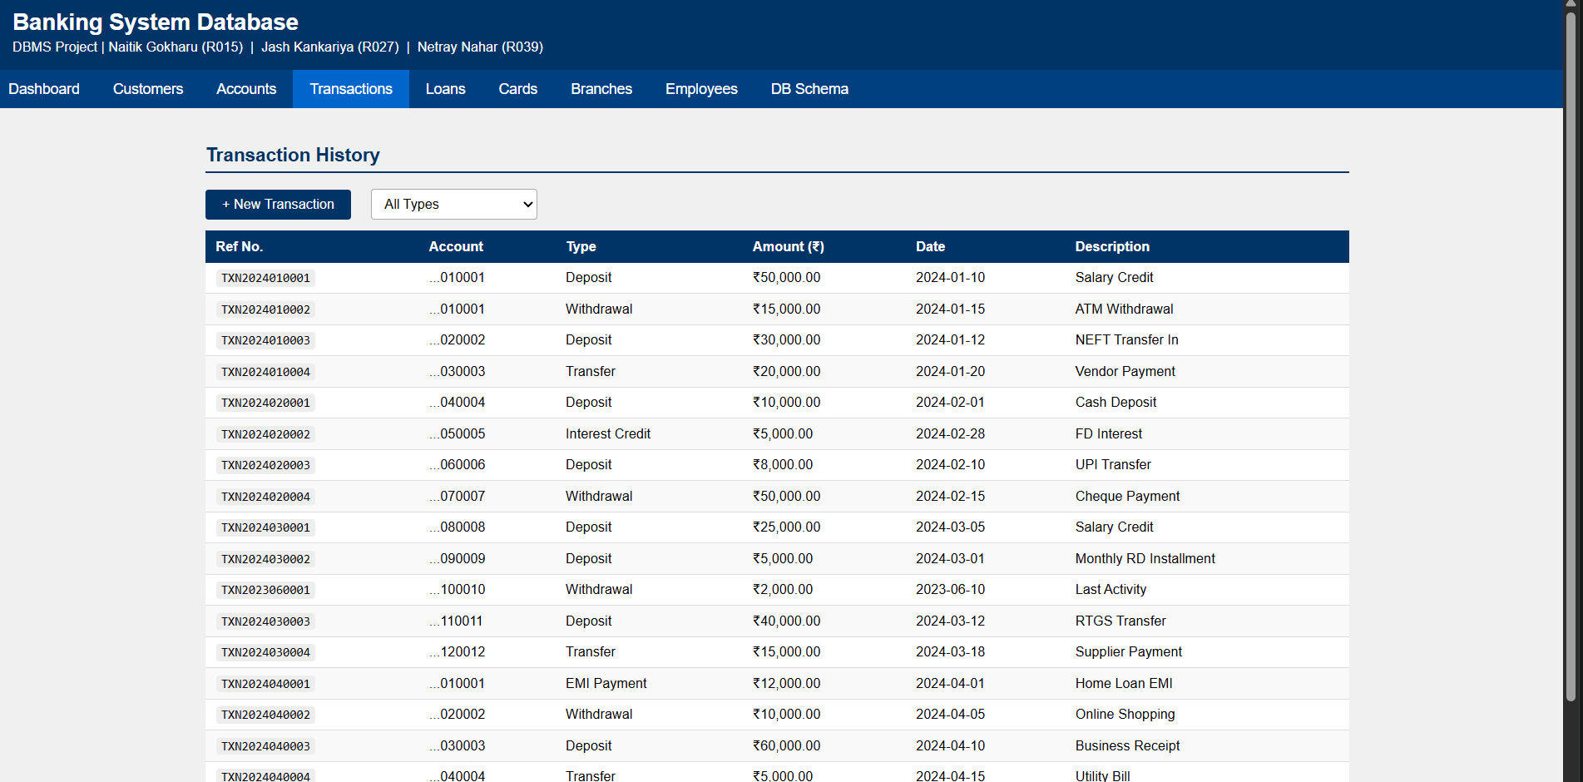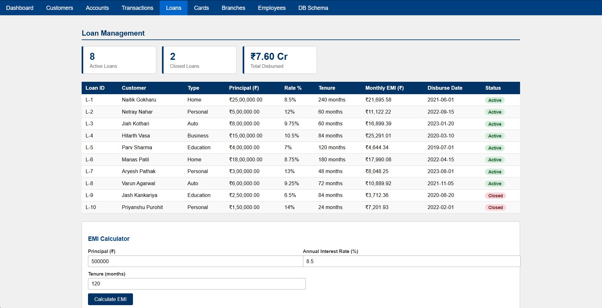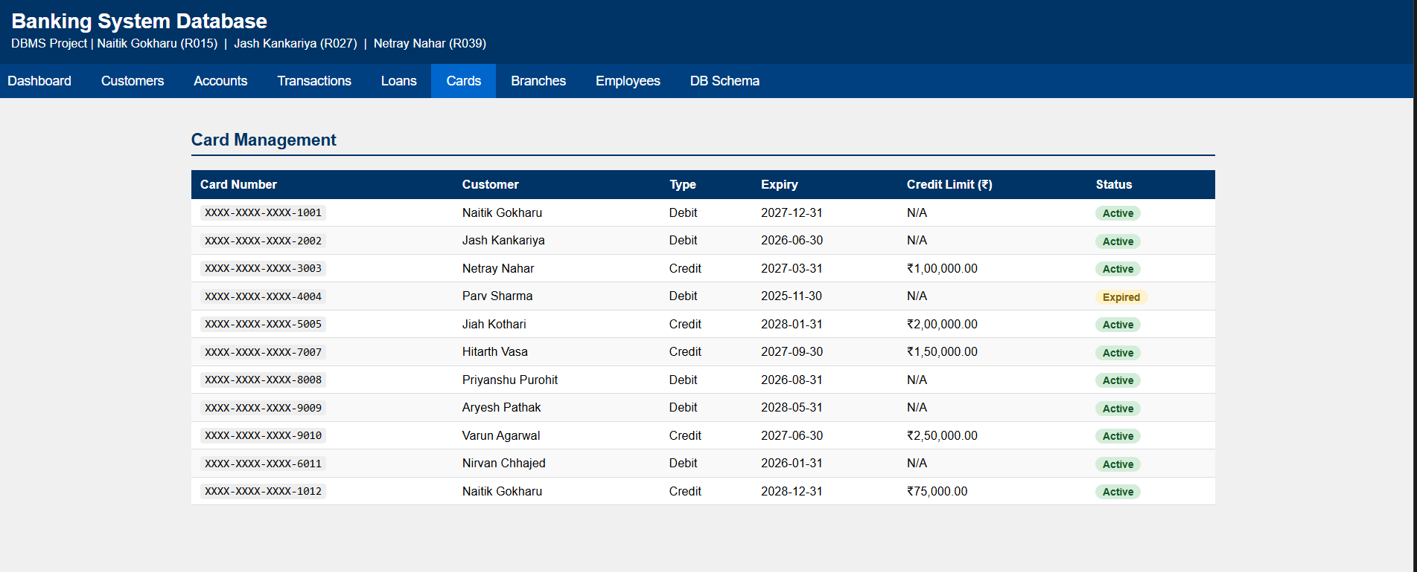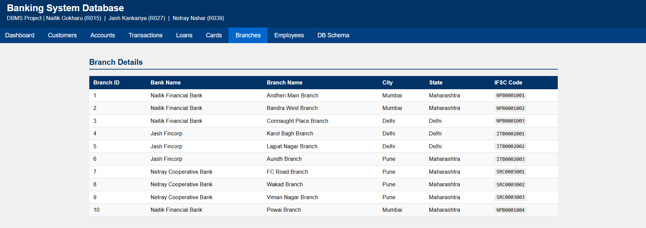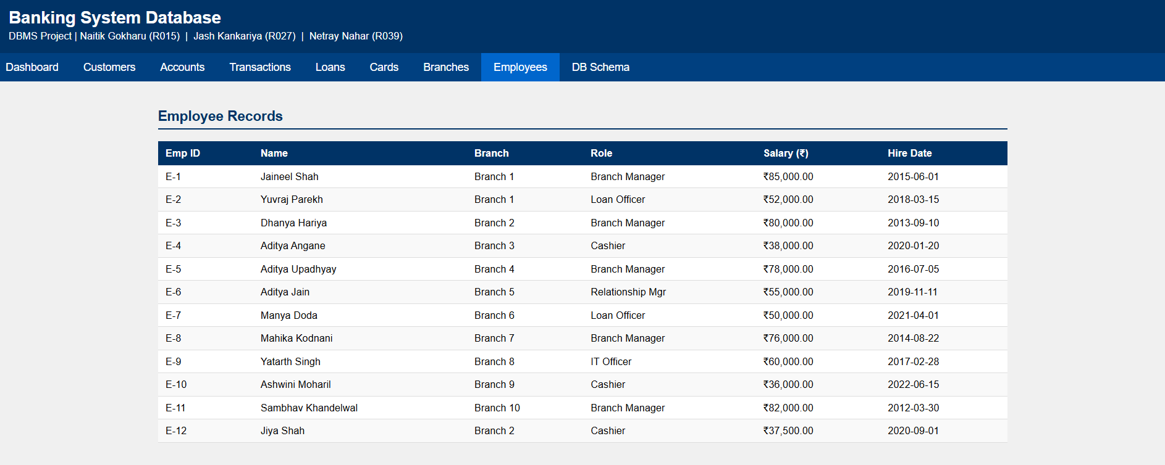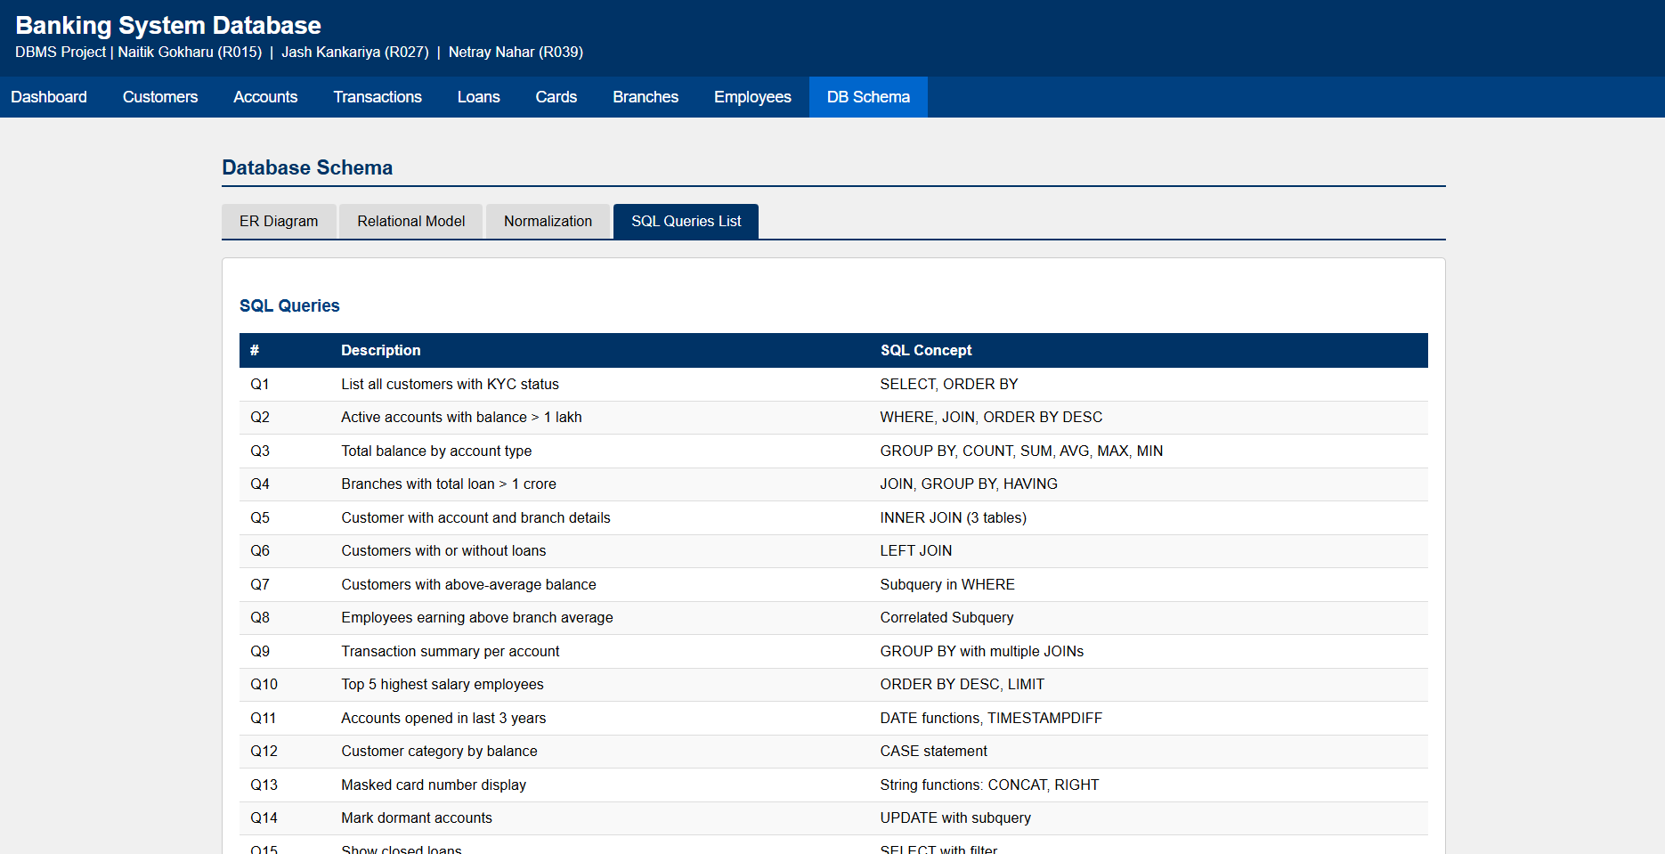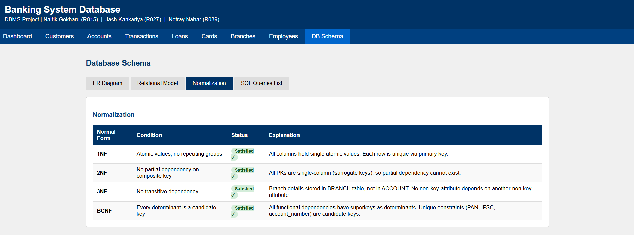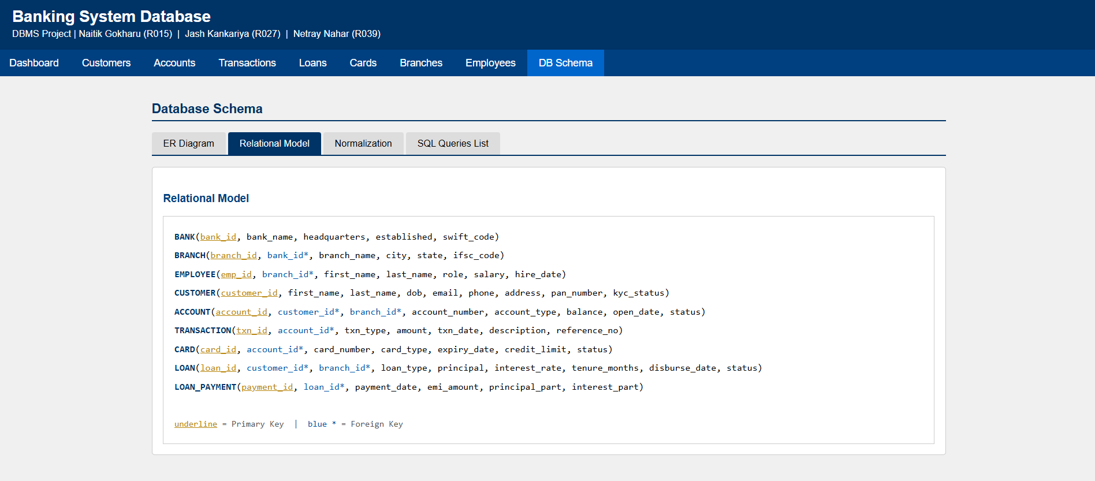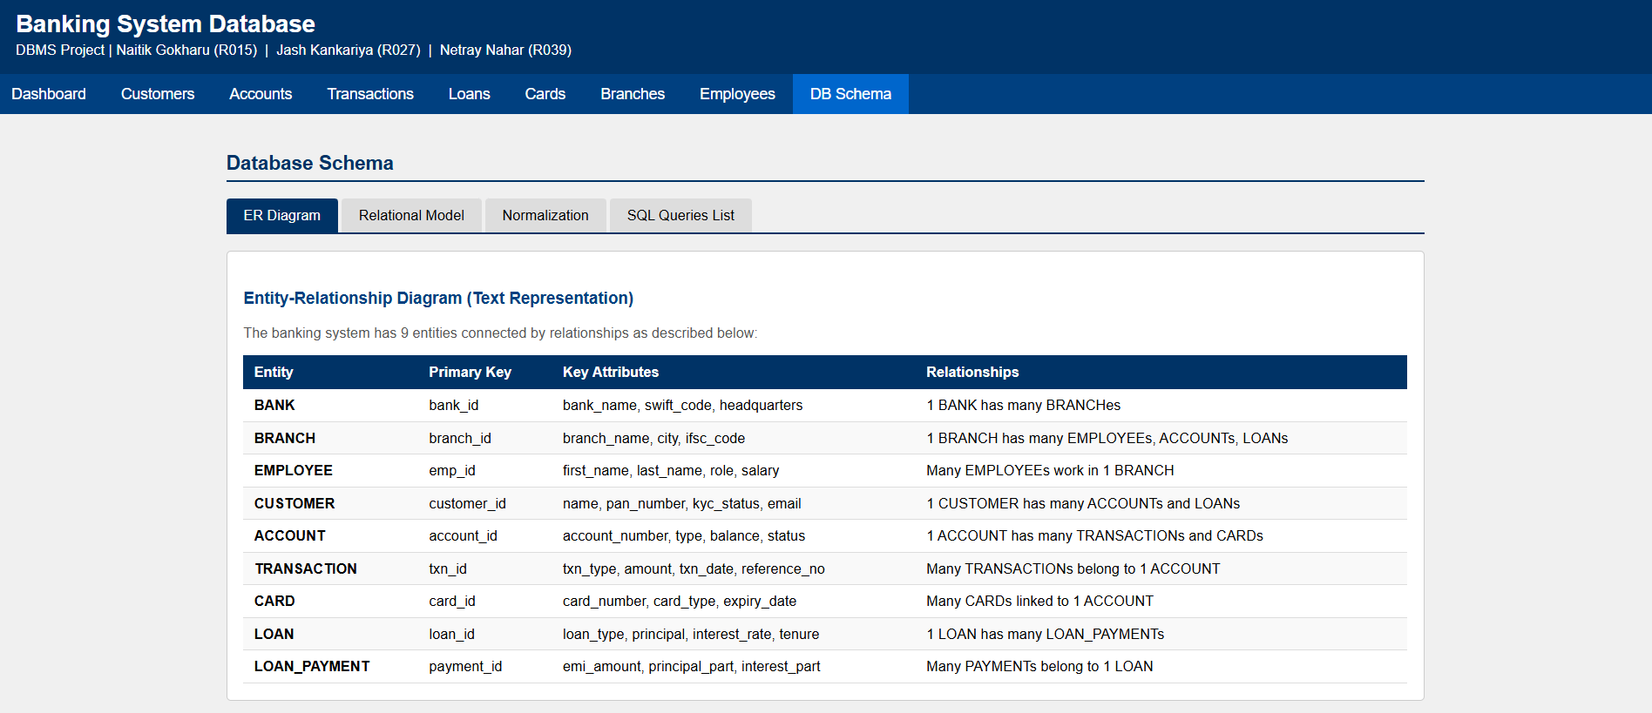

VII. Self -Learning beyond classroom
:
- What new aspects did you learn on your own ? You have to mention learning beyond the classroom
The following concepts were learned independently beyond classroom syllabus:
- AUTO_INCREMENT and Surrogate Keys : Learned how MySQL automatically manages primary key generation and why integer surrogate keys are preferred over natural keys for performance and referential integrity.
- ON DELETE CASCADE and ON DELETE SET NULL : Learned how to define referential integrity actions when a parent record is deleted, and the difference between cascading deletes and nullifying foreign keys.
- COALESCE() Function : Learned how to handle NULL values in aggregation queries, substituting a default value when no matching records exist in a LEFT JOIN.
- EMI Formula in SQL : Self-researched the standard reducing balance EMI formula (P × r × (1+r)^n / ((1+r)^n − 1)) and implemented it using MySQL's POW() mathematical function.
- CREATE VIEW : Learned how database views act as virtual tables to simplify repeated complex queries and separate logic from application code.
- MySQL Error 1830 Debugging : Encountered and resolved a real MySQL 9.6 constraint error where a foreign key column with ON DELETE SET NULL cannot be declared NOT NULL : a practical debugging scenario not covered in class.
- 3-Tier Architecture Concept : Learned how real banking applications use Browser → Application Server → Database architecture, even though our project uses a static HTML frontend.

VIII. Learning from the Project

Include learning from the project:
How this project helped you?
- Database Design Thinking: Designing a real-world schema required thinking about relationships, redundancy, and data separation : skills that textbook examples alone cannot develop.
- Normalization in Practice: Applying 1NF through BCNF to 9 tables made abstract normalization concepts clear. We could directly see why separating branch details from accounts prevents update anomalies.
- SQL Query Diversity: Writing 22 queries covering GROUP BY, subqueries, correlated subqueries, transactions, views, and string functions gave a comprehensive understanding of SQL beyond simple SELECT statements.
- Debugging Real Errors: Fixing MySQL Error 1830 by understanding NULL constraints and foreign key rules taught us practical database error handling.
- Frontend + Backend Separation: Building both a GUI and a database helped us understand how end users interact with data through interfaces and why database design decisions affect application behavior.
- Teamwork: Dividing schema design, query writing, and frontend development taught us how real software projects are structured and integrated across team members.

IX. Challenges Faced

- MySQL Error 1830 (Foreign Key + NOT NULL conflict): When creating the EMPLOYEE table, MySQL 9.6 rejected the schema because a column declared NOT NULL was used as a foreign key with ON DELETE SET NULL. This required researching MySQL documentation to understand and resolve.
- Schema Design Decisions: Deciding how many tables were needed, what attributes belonged where, and how to avoid redundancy while keeping the design practical required multiple revisions.
- Correlated Subqueries: Understanding how a correlated subquery re-executes for each outer query row was conceptually challenging. Query Q8 required multiple attempts to get correct.
- EMI Formula in SQL: Implementing the compound interest formula in a single SQL expression using POW() required careful attention to operator precedence and mathematical accuracy.
- Consistent Data Population: Populating all 9 tables with realistic, internally consistent data : ensuring all foreign keys reference valid records : was time-consuming but essential for queries to produce meaningful results.

X. Conclusion

What are the key takeaways from the project?
The Banking System Database project successfully demonstrates the end-to-end design and implementation of a relational database for a real-world banking scenario. Starting from requirements gathering, the project covered all phases: entity identification, ER diagram construction, relational model conversion, normalization up to BCNF, schema implementation in MySQL, data population, and execution of 22 diverse SQL queries.
Key takeaways:
- A well-normalized schema eliminates redundancy, prevents anomalies, and ensures data consistency
- SQL is a powerful language capable of handling complex analytical queries with minimal code
- Real-world implementation always reveals challenges that theory alone cannot prepare you for
- Frontend interfaces help translate abstract database concepts into tangible, user-friendly applications
This project has strengthened our understanding of database systems and prepared us to design, implement, and query relational databases for real-world applications in our future careers.

